- VU1530B Double Column Machining Center

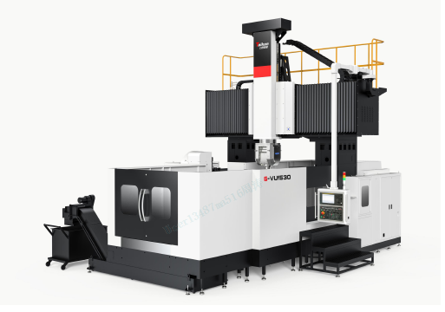

1.Equipment technical description
G-VU1530 double column machining center (3+2 five-axis non-linkage) is mainly used for processing complex parts, processing aluminum and its alloys, and processing difficult-to-machine materials. It can process complex spatial surfaces with high precision and efficiency.
- The whole machine structure: the machine adopts the double column frame fixed, the worktable moving structure. The foundation large parts are made of high quality resin sand molding and high strength cast iron material, so that the machine can get high rigidity and stable accuracy. The main castings have been analyzed by finite element analysis, and the grid layout is reasonable, which fully meets the needs of high torque cutting of the machine tool.
- Spindle: The spindle unit adopts mepro T70.5 five-axis linkage A/C double swing milling head, which can realize five-axis machining of complex curved surfaces. Through high-precision encoders and hydraulic tensioning systems, the A and C axes can be clamped at any angle within the operating range (C axis ±360°, A axis ±110°). The standard 18000rpm electric spindle can perform high-precision, fast and continuous cutting (see the below picture).
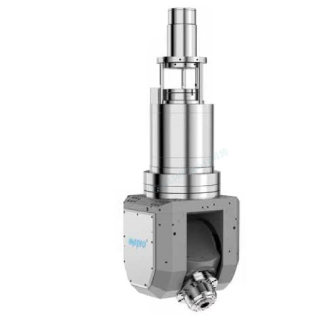
- Guideways: The bed guideways (X-axis), beam guideways (Y-axis) and ram guideways (Z-axis) all adopt imported heavy-duty roller guideways, which have low friction, strong load-bearing capacity, low high-speed vibration, and no crawling at low speeds. High positioning accuracy. The crossbeam guide rail adopts a stepped arrangement to increase the guide rail span and improve the load-bearing capacity. It has good load-bearing performance and ensures stable cutting during processing.
- Drive: The three feed axes of X, Y and Z are all driven by feed motors, which have good stability and reliable operation. The X-axis and Y-axis use large-lead ball screw drive structures; the Z-axis uses a motor directly connected to the ball screw, and the Z-axis uses a nitrogen balance cylinder to balance the weight of the ram.
- System: Equipped with a high-performance SIEMENS 828D CNC system to ensure the stability of machine tool control and the CNC processing functions and auxiliary functions required by users.
- Working conditions:
- Power supply: three-phase AC 380V±10%; 50Hz±1Hz; the machine tool should have reliable grounding: the grounding wire is a copper wire ≥25mm²; the grounding resistance is <4Ω.
- In order to keep the static accuracy of the machine tool within the guaranteed value range, the machine tool should be installed in an area not affected by air flow. It is necessary to keep the surrounding temperature between 17℃~25℃, the humidity between 40% and 75%, and The ambient temperature change within 24 hours should be within ±2°C, and the ambient temperature change from the ground to about 5 meters high should be maintained within 2°C.
- If the requirements for the parts being processed are not high, the ambient temperature range can be relaxed to 10°C ~ 40°C.
- Keep away from light sources, vibration sources and heat sources, and away from high-frequency generators, discharge motors, welding machines, etc. to avoid electrical interference that may cause the machine tool NC system to malfunction.
- If the voltage in the area where it is used is unstable, the machine tool should be equipped with a regulated power supply to ensure the normal operation of the machine tool.
- In order to ensure the normal operation of the equipment, if the compressed air source does not meet the cleanliness requirements, an air source purification device (dehumidification, oil removal, filtration) should be added before the air intake of the machine tool.
- In order to maintain the accuracy and stability of the machine tool, the foundation must be made in strict accordance with the requirements of the foundation map provided by the company. When the user chooses to sink the machine tool, the user-made protective covers and support parts for the foundation anti-seismic ditch and sinking pit; our company provides the necessary technology support.
2. Equipment parameters
Name |  |  | Unit | Parameters | Remark
Processing range | X axis |  | mm | 3200
Processing range | Y axis |  | mm | 2700
Processing range | Z axis |  | mm | 1000
Processing range | Distance from spindle end face to worktable |  | mm | 100～1100
Processing range | Spindle swing arm length |  | mm | 329.2
Processing range | Effective door width |  | mm | 2450
Worktable | Size |  | mm | 1500*3000
Worktable | Max load |  | Kg | 10000
Worktable | T-shaped slot |  | mm | 28
Spindle | Spindle motor power |  | KW | 30
Spindle | Spindle speed |  | rpm | 18000
Spindle | Output torque |  | Nm | 72Nm-S1, 85Nm-S6
Spindle | Taper |  | mm | HSK-A63
Spindle | A-axis swing angle |  |  | ±110°
Spindle | C-axis swing angle |  |  | ±360°
Spindle | Max.A/C axis rotation |  | rpm | 60
Speed | Cutting feed speed range |  | mm/min | 10000/10000/10000
Speed | X, Y, Z axis rapid movement speed |  | mm/min | 15000/15000/15000
Precision | Positioning accuracy（X/Y/Z） |  | No grating | 0.027/0.024/0.016
Precision |  |  | With grating | 0.023/0.021/0.014
Precision | Repeat positioning accuracy（X/Y/Z） |  | No grating | 0.017/0.014/0.012
Precision |  |  | With grating | 0.015/0.013/0.011
Precision | Positioning accuracy（A/C） |  |  | 8″（VD13441）/8″（VD13441）
Precision | Repeat positioning accuracy（A/C） |  |  | 4″（VD13441）/4″（VD13441）
Other | Z-axis counterweight |  |  | Oil pressure + nitrogen balance
Other | CNC system |  |  | SIEMENS 828D
Other | Air | Flow | L/min | 500
Other | Air | Air pressure | MPa | 0.6∼0.8
Other | Cooling box volume |  | L | 750
Other | Machine tool appearance dimensions |  | mm | 7800*6100*6000
Other | Machine tool sheet metal protection |  | Set | Fully protective sheet metal | No cap

3、Equipment standard configuration

No. | Item | No. | Item
1 | CNC System： SIEMENS 828D | 13 | Hydraulic station
2 | 15-inch monitor | 14 | Five-axis double swing milling head (electric spindle)
3 | Handheld operating unit | 15 | Crossbeam guide rail protective cover
4 | Hanging operation panel | 16 | Bed guide rail protective cover
5 | Pneumatic system | 17 | Three-color signal light
6 | Clean airgun | 18 | lighting device
7 | Automatic lubrication system | 19 | Electric cabinet air conditioner
8 | Spindle cooling system | 20 | Ram Nitrogen Balance System
9 | Workpiece cooling system | 21 | Basic installation kit
10 | Chain plate chip conveyor + chip collecting car | 22 | Technical documents
11 | Spiral chip conveyor
12 | Gearbox cooling system (oil cooling)

4、Customer chooses configuration
4.1 CNC System
No. | Item | Whether to choose | Remark
1 | FANUC 0I-MF PLUS (1) System | □ | High-end mold processing
2 | (A02B-0304-R522; A02B-0304-J998 inclined surface processing and 3D hand wheel return function) | □ | If you select this option, you must also select the FANUC 0I-MF PLUS(1) system

2. Brands of main parts of equipment
No. | Item | Brand | Remark
1 | Controller system | SIEMENS | GERMAN
2 | Spindle unit | mepro | Domestic
3 | Ball screw | PMI/HIWIN | Taiwan
4 | Screw bearing | NSK | Japan
5 | Guideways | PMI/HIWIN /INA | Taiwan/Germany
6 | Lubrication system | BAOTENG | Domestic
7 | Main pneumatic components | SMC | Japan
8 | Spindle water cooler machine | Saiyang | Domestic
9 | Electrical cabinet air conditioner | Tongfe | Domestic
10 | Main electrical components | Schneider | France

Note: The manufacturer reserves the right to replace the product with the same brand

3. Equipment recommended oil and grease table
Use widgets | Name | Capacity | Recommended oil |  | Remark
hydraulic station | Anti-wear hydraulic oil | 5.5L | Shell: TELLUS S2 M32 | Winter | Replace it after 3 months of initial use; replace it every 6 months thereafter
hydraulic station | Anti-wear hydraulic oil | 5.5L | Great Wall: L-HM 32;  Shell: TELLUS S2 M32 | Summer
spindle cooler | Anti-wear hydraulic oil | 40L | Shell: TELLUS S2 M32 | Winter | Replace it after 3 months of initial use; replace it every 6 months thereafter
spindle cooler | Anti-wear hydraulic oil | 40L | Great Wall: L-HM 32;  Shell: TELLUS S2 M32 | Summer
A/C axis water cooler | Antifreeze coolant | 40L | BASF (BASF): Gulishun G48;  Mobil: -45℃ antifreeze coolant |  | Replace it after 6 months of initial use; replace it every 12 months thereafter
Lubrication pump | Extreme pressure lithium grease | 2L | Great Wall: 00#;  Shell: Gadus S2 V220 00# | Winter | Refill when the oil level is below the minimum level line
Lubrication pump | Extreme pressure lithium grease | 2L | Great Wall: 00#;  Shell: Gadus S2 V220 00# | Summer | Refill when the oil level is below the minimum level line

